截圖佐證是自己操作

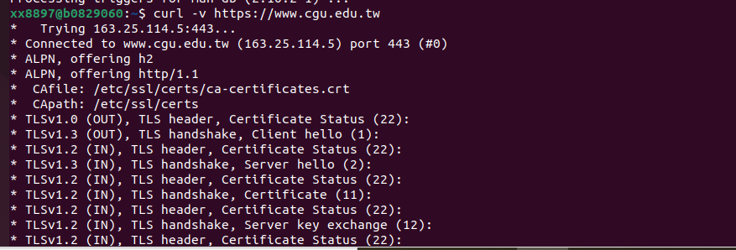

這裡開始是html

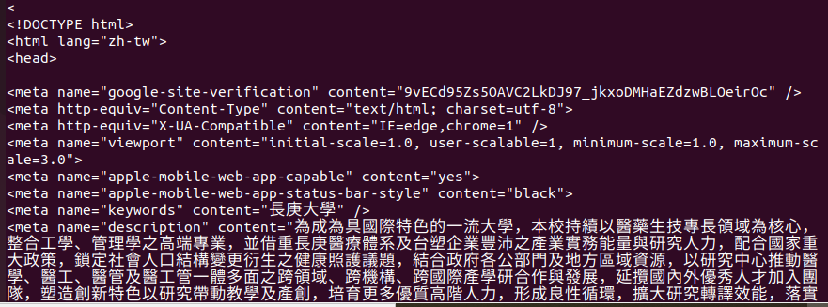

html結束

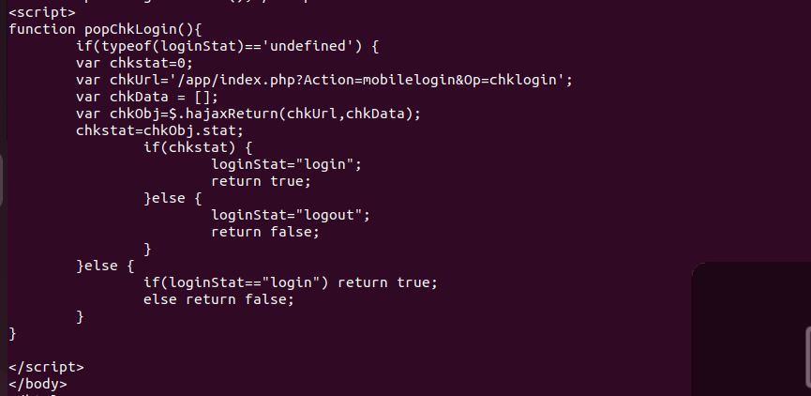

html連接

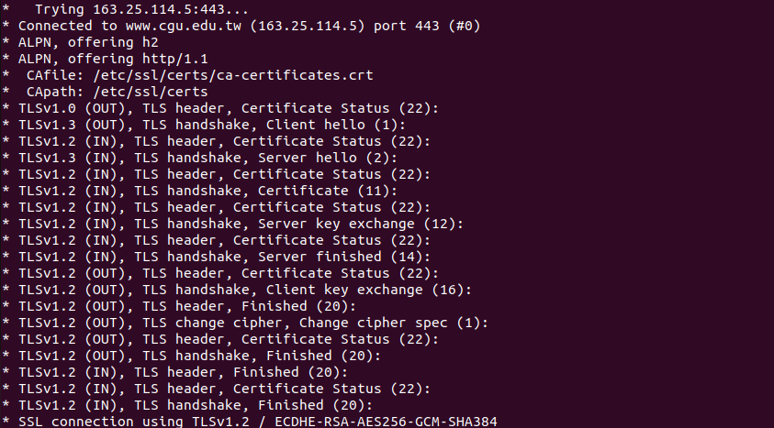

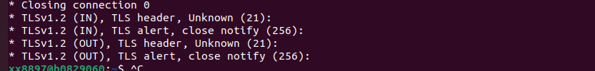

certificate區塊

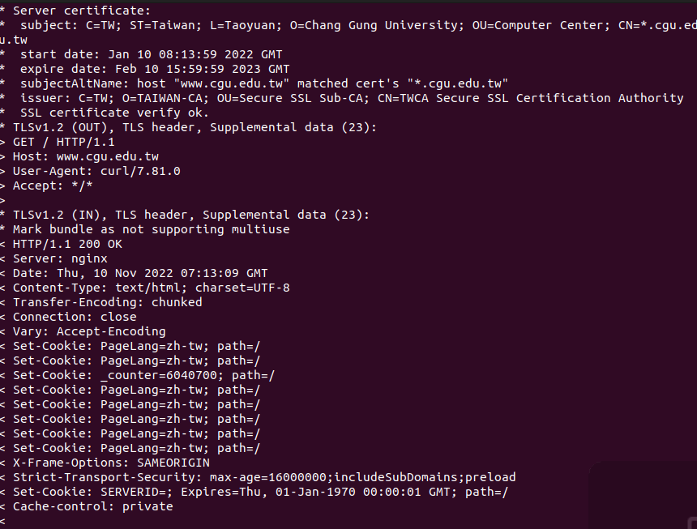

* Trying 163.25.114.5:443...

* Connected to www.cgu.edu.tw (163.25.114.5) port 443 (#0)

* ALPN, offering h2

* ALPN, offering http/1.1

* CAfile: /etc/ssl/certs/ca-certificates.crt

* CApath: /etc/ssl/certs

* TLSv1.0 (OUT), TLS header, Certificate Status (22):

* TLSv1.3 (OUT), TLS handshake, Client hello (1):

* TLSv1.2 (IN), TLS header, Certificate Status (22):

* TLSv1.3 (IN), TLS handshake, Server hello (2):

* TLSv1.2 (IN), TLS header, Certificate Status (22):

* TLSv1.2 (IN), TLS handshake, Certificate (11):

* TLSv1.2 (IN), TLS header, Certificate Status (22):

* TLSv1.2 (IN), TLS handshake, Server key exchange (12):

* TLSv1.2 (IN), TLS header, Certificate Status (22):

* TLSv1.2 (IN), TLS handshake, Server finished (14):

* TLSv1.2 (OUT), TLS header, Certificate Status (22):

* TLSv1.2 (OUT), TLS handshake, Client key exchange (16):

* TLSv1.2 (OUT), TLS header, Finished (20):

* TLSv1.2 (OUT), TLS change cipher, Change cipher spec (1):

* TLSv1.2 (OUT), TLS header, Certificate Status (22):

* TLSv1.2 (OUT), TLS handshake, Finished (20):

* TLSv1.2 (IN), TLS header, Finished (20):

* TLSv1.2 (IN), TLS header, Certificate Status (22):

* TLSv1.2 (IN), TLS handshake, Finished (20):

* SSL connection using TLSv1.2 / ECDHE-RSA-AES256-GCM-SHA384

* ALPN, server did not agree to a protocol

* Server certificate:

* subject: C=TW; ST=Taiwan; L=Taoyuan; O=Chang Gung University; OU=Computer Center; CN=*.cgu.edu.tw

* start date: Jan 10 08:13:59 2022 GMT

* expire date: Feb 10 15:59:59 2023 GMT

* subjectAltName: host "www.cgu.edu.tw" matched cert's "*.cgu.edu.tw"

* issuer: C=TW; O=TAIWAN-CA; OU=Secure SSL Sub-CA; CN=TWCA Secure SSL Certification Authority

* SSL certificate verify ok.

* TLSv1.2 (OUT), TLS header, Supplemental data (23):

> GET / HTTP/1.1

> Host: www.cgu.edu.tw

> User-Agent: curl/7.81.0

> Accept: */*

>

* TLSv1.2 (IN), TLS header, Supplemental data (23):

* Mark bundle as not supporting multiuse

< HTTP/1.1 200 OK

< Server: nginx

< Date: Thu, 10 Nov 2022 07:13:09 GMT

< Content-Type: text/html; charset=UTF-8

< Transfer-Encoding: chunked

< Connection: close

< Vary: Accept-Encoding

< Set-Cookie: PageLang=zh-tw; path=/

< Set-Cookie: PageLang=zh-tw; path=/

< Set-Cookie: _counter=6040700; path=/

< Set-Cookie: PageLang=zh-tw; path=/

< Set-Cookie: PageLang=zh-tw; path=/

< Set-Cookie: PageLang=zh-tw; path=/

< Set-Cookie: PageLang=zh-tw; path=/

< Set-Cookie: PageLang=zh-tw; path=/

< X-Frame-Options: SAMEORIGIN

< Strict-Transport-Security: max-age=16000000;includeSubDomains;preload

< Set-Cookie: SERVERID=; Expires=Thu, 01-Jan-1970 00:00:01 GMT; path=/

< Cache-control: private

<

<!DOCTYPE html>

<html lang="zh-tw">

<head>

<meta name="google-site-verification" content="9vECd95Zs5OAVC2LkDJ97_jkxoDMHaEZdzwBLOeirOc" />

<meta http-equiv="Content-Type" content="text/html; charset=utf-8">

<meta http-equiv="X-UA-Compatible" content="IE=edge,chrome=1" />

<meta name="viewport" content="initial-scale=1.0, user-scalable=1, minimum-scale=1.0, maximum-scale=3.0">

<meta name="apple-mobile-web-app-capable" content="yes">

<meta name="apple-mobile-web-app-status-bar-style" content="black">

<meta name="keywords" content="長庚大學" />

<meta name="description" content="為成為具國際特色的一流大學，本校持續以醫藥生技專長領域為核心，整合工學、管理學之高端專業，並借重長庚醫療體系及台塑企業豐沛之產業實務能量與研究人力，配合國家重大政策，鎖定社會人口結構變更衍生之健康照護議題，結合政府各公部門及地方區域資源，以研究中心推動醫學、醫工、醫管及醫工管一體多面之跨領域、跨機構、跨國際產學研合作與發展，延攬國內外優秀人才加入團隊，塑造創新特色以研究帶動教學及產創，培育更多優質高階人力，形成良性循環，擴大研究轉譯效能，落實回饋社會之大學責任。" />

<title>長庚大學 - 長庚大學資訊網</title>

<link rel="shortcut icon" href="/var/file/0/1000/msys_1000_6880323_92563.png" type="image/x-icon" />

<link rel="icon" href="/var/file/0/1000/msys_1000_6880323_92563.png" type="image/x-icon" />

<link rel="bookmark" href="/var/file/0/1000/msys_1000_6880323_92563.png" type="image/x-icon" />

<link rel="apple-touch-icon-precomposed" href="/var/file/0/1000/msys_1000_6880323_92563.png">

<link rel="stylesheet" href="/var/file/0/1000/mobilestyle/combine-zh-tw.css?t=1665736867" type="text/css" />

<script language="javascript"><!--

var isHome = true

--></script>

<script language="javascript"><!--

var isExpanMenu = false

--></script>

<script type="text/javascript" src="/var/file/js/m_20221014.js" ></script>

</head>

<body class="page_mobilehome webfree ">

<div class="wrap">

<a href="#start-C" class="focusable" title="跳到主要內容區">跳到主要內容區</a>

<div class="fpbgvideo"></div>

<div class="minner">

<div id="Dyn_head">

<div class="header">

<div class="minner ">

<div class="selfhead">

<div class="meditor">

<div class="head container">

<div class="logo"><h1><a href="/index.php?Lang=zh-tw" title="長庚大學"><img alt="長庚大學 校徽logo" src="/var/file/0/1000/img/2299/logo.png"></a></h1></div>

<div class="msearch">

<a aria-expanded="false" class="btn btn-primary navbar-toggle1 sch-toggle" data-toggle="collapse" href="#headsearch" role="button"><span>Search</span></a>

<div class="collapse" id="hdsearch">

<div class="googlesearch">

<form action="https://www.google.com/search" method="get">

<table>

<tbody>

<tr>

<td>

<label for="q"></label>

<input class="gsch_txt" name="q" id="q" placeholder="搜尋"/>

<input name="hl" type="hidden" id="hl" value="zh-tw" />

<input name="sitesearch" id="sitesearch" type="hidden" value="cgu.edu.tw"/>

<input class="gsch_btn" name="btnG" id="btnG" type="submit" value="Search" /></td>

</tr>

</tbody>

</table>

</form>

</div>

</div>

</div>

<div class="mycollapse">

<button class="navbar-toggle" data-target=".nav-toggle" data-toggle="collapse" type="button"><span class="glyphicons show_lines">Menu</span></button>

<div class="navbar-collapse collapse nav-toggle" id="collapseExample2">

<div class="topnav">

<div class="headnavcust">

<div class="mnavbar mn-collapse">

<button type="button" class="navbar-toggle" data-toggle="collapse" data-target=".hd-topnav">

<span class="glyphicons show_lines">Menu</span>

</button>

<div class="nav-toggle collapse navbar-collapse iosScrollToggle hd-topnav">

<div class="hdmenu">

<ul class="nav navbar-nav" id="a2acffae17a30791ce64619d35e5d2546_MenuTop_topnav">

<li id="Hln_5560" ><a href="/p/17-1000.php?Lang=zh-tw" title="網站導覽">網站導覽</a></li>

<li id="Hln_5561" ><a href="/index.php?Lang=en" title="EN">EN</a></li>

<li id="Hln_5562" ><a href="/index.php?Lang=zh-cn" title="简">简</a></li>

<li id="Hln_5563" ><a href="http://mycgu.blogspot.com/2017/04/app-index.html" target="_blank" title="行動APP(另開新視窗)">行動APP</a></li>

</ul>

</div>

</div>

</div>

</div>

<script>

$(document).ready(function(){

$(".mnavbar .navbar-toggle").click(function(){

$(this).toggleClass("open");

});

$('.iosScrollToggle').on('shown.bs.collapse', function () {

var togglePos = $(this).css('position');

if(togglePos !== 'static'){

ModalHelper.afterOpen();

}

});

$('.iosScrollToggle').on('hide.bs.collapse', function () {

var togglePos = $(this).css('position');

if(togglePos !== 'static'){

ModalHelper.beforeClose();

}

});

});

</script>

<script language="javascript">

tabSwitch("a2acffae17a30791ce64619d35e5d2546_MenuTop_topnav");

</script>

</div>

<div class="mainmenu">

<div class="headnavcust">

<div class="mnavbar mn-collapse">

<button type="button" class="navbar-toggle" data-toggle="collapse" data-target=".hd-mainmenu">

<span class="glyphicons show_lines">Menu</span>

</button>

<div class="nav-toggle collapse navbar-collapse iosScrollToggle hd-mainmenu">

<div class="hdmenu">

<ul class="nav navbar-nav" id="a2acffae17a30791ce64619d35e5d2546_MenuTop_mainmenu">

<li id="Hln_5570" ><a href="/p/412-1000-4457.php?Lang=zh-tw" title="校園資訊">校園資訊</a></li>

<li id="Hln_5571" ><a href="/p/412-1000-146.php?Lang=zh-tw" title="教學研究">教學研究</a></li>

<li id="Hln_5572" ><a href="/p/412-1000-147.php?Lang=zh-tw" title="行政服務">行政服務</a></li>

<li id="Hln_5573" ><a href="http://recruit.cgu.edu.tw/index.php?Lang=zh-tw" target="_blank" title="招生資訊(另開新視窗)">招生資訊</a></li>

<li id="Hln_5574" ><a href="http://library.cgu.edu.tw/" target="_blank" title="圖書館(另開新視窗)">圖書館</a></li>

<li id="Hln_5575" ><a href="http://www.fpgmuseum.com.tw" target="_blank" title="企業文物館(另開新視窗)">企業文物館</a></li>

<li id="Hln_5576" ><a href="http://oia.cgu.edu.tw/" target="_blank" title="國際事務處(另開新視窗)">國際事務處</a></li>

</ul>

</div>

</div>

</div>

</div>

<script language="javascript">

tabSwitch("a2acffae17a30791ce64619d35e5d2546_MenuTop_mainmenu");

</script>

</div>

<div class="mobileMenu">

<div class="headnavcust">

<div class="mnavbar mn-collapse">

<button type="button" class="navbar-toggle" data-toggle="collapse" data-target=".hd-mobileMenu">

<span class="glyphicons show_lines">Menu</span>

</button>

<div class="nav-toggle collapse navbar-collapse iosScrollToggle hd-mobileMenu">

<div class="hdmenu">

<ul class="nav navbar-nav" id="a2acffae17a30791ce64619d35e5d2546_MenuTop_mobileMenu">

<li id="Hln_8421" ><a href="http://highschool.cgu.edu.tw/" target="_blank" title="高中生(另開新視窗)">高中生</a></li>

<li id="Hln_5564" ><a href="http://freshman.cgu.edu.tw/" target="_blank" title="新生入學(另開新視窗)">新生入學</a></li>

<li id="Hln_5565" ><a href="/p/412-1000-9886.php?Lang=zh-tw" title="在校學生">在校學生</a></li>

<li id="Hln_5568" ><a href="https://www.cgu.edu.tw/p/412-1000-9887.php?Lang=zh-tw" title="教職員工">教職員工</a></li>

<li id="Hln_5567" ><a href="http://cguas.cgu.edu.tw/" target="_blank" title="畢業校友(另開新視窗)">畢業校友</a></li>

<li id="Hln_5569" ><a href="http://cgunews.cgu.edu.tw/" target="_blank" title="媒體訪客(另開新視窗)">媒體訪客</a></li>

<li id="Hln_5566" ><a href="https://oia.cgu.edu.tw/" target="_blank" title="International Students(另開新視窗)">International Students</a></li>

</ul>

</div>

</div>

</div>

</div>

<script language="javascript">

tabSwitch("a2acffae17a30791ce64619d35e5d2546_MenuTop_mobileMenu");

</script>

</div>

</div>

</div>

</div>

<div id="banner"></div>

<div id="links" class="container"></div>

<script>

$(document).ready(function(){

$.hajaxOpenUrl("/app/index.php?Action=mobileloadmod&Type=mobile_sz_mstr&Nbr=253",'#banner');

$.hajaxOpenUrl("/app/index.php?Action=mobileloadmod&Type=mobile_ln_mstr&Nbr=284",'#links');

$(".sch-toggle").click(function(){

$(".sch-toggle").toggleClass("open");

});

});

</script>

</div>

</div>

</div>

</div>

<script language="javascript">

tabSwitch("a2acffae17a30791ce64619d35e5d2546_MenuTop");

if(typeof(_LoginHln)=='undefined') var _LoginHln = new hashUtil();

if(typeof(_LogoutHln)=='undefined') var _LogoutHln = new hashUtil();

if(typeof(_HomeHln)=='undefined') var _HomeHln = new hashUtil();

if(typeof(_InternalHln)=='undefined') var _InternalHln = new hashUtil();

$(document).ready(function(){

if(typeof(loginStat)=='undefined') {

if(popChkLogin()) loginStat="login";

else loginStat="logout";

}

dealHln(isHome,loginStat,$('div.hdmenu'));

var html ="<li><a title=\"上方內容區\" accesskey=\"U\" href=\"#\" class=\"hd-accesskey\">:::</a></li>";

var anchor = "topnav";

var hlnCgId = "a2acffae17a30791ce64619d35e5d2546_MenuTop_"+anchor;

var headMenuId = "a2acffae17a30791ce64619d35e5d2546_MenuTop";

if($("#"+hlnCgId).length>0){

$("#"+hlnCgId).prepend(html);

}else{

if($("#"+headMenuId).length>0)

$("#"+headMenuId).prepend(html);

}

});

</script>

<noscript>本功能需使用支援JavaScript之瀏覽器才能正常操作</noscript>

<!-- generated at Thu Oct 27 2022 10:04:14 --></div>

<div class="main">

<div class="minner">

<div class="row col1 row_0">

<div class="mrow container">

<div class="col col_02">

<div class="mcol">

<div id="Dyn_2_1" class="M42 ">

<div class="module module-um md_style99">

<div class="mouter">

<header class="mt mthide ">

</header>

<section class="mb">

<div class="minner">

<div class="meditor">

<a href="#start-C" title='主要內容區' accesskey="C" style="text-decoration:none" id="start-C">:::</a>

</div>

</div>

</section>

</div>

</div>

<!-- generated at Fri Oct 14 2022 16:41:38 --></div>

<div id="Dyn_2_2" class="M10217 ">

<div class="module module-special md_style1">

<div class="mouter">

<header class="mt ">

<h2 class="mt-title">新訊特報</h2>

</header>

<section class="mb">

<div class="_special_listSlide_2_2_a845076150ea6bd09d9430129606f1a51 row listBS listSlide owl-carousel">

<div class="d-item v-it col-sm-12">

<div class="mbox">

<div class="d-img">

<a><img src="/var/file/0/1000/pictures/259/m/mczh-tw1200x400_small71441_281974893174.png" class="img-responsive" alt="" /></a>

</div>

<div class="d-txt">

<div class="mtitle">

<a href="http://prevention.cgu.edu.tw/" target="_blank" title="長庚大學 嚴重特殊傳染性肺炎 (COVID-19) 防疫專區(另開新視窗)">

長庚大學 嚴重特殊傳染性肺炎 (COVID-19) 防疫專區

</a>

</div>

</div>

</div>

</div>

<div class="d-item v-it col-sm-12">

<div class="mbox">

<div class="d-img">

<a><img src="/var/file/0/1000/pictures/197/m/mczh-tw1200x400_small99128_348961686180.png" class="img-responsive" alt="" /></a>

</div>

<div class="d-txt">

<div class="mtitle">

<a href="https://studentaffairs.cgu.edu.tw/p/412-1012-9808.php?Lang=zh-tw" target="_blank" title="長庚大學111學年度運動會x親子日(另開新視窗)">

長庚大學111學年度運動會x親子日

</a>

</div>

</div>

</div>

</div>

<div class="d-item v-it col-sm-12">

<div class="mbox">

<div class="d-img">

<a><img src="/var/file/0/1000/pictures/782/m/mczh-tw1200x400_small97935_366712263175.jpg" class="img-responsive" alt="" /></a>

</div>

<div class="d-txt">

<div class="mtitle">

<a href="https://recruit.cgu.edu.tw/p/405-1041-97567,c1820.php?Lang=zh-tw" title="112學年度碩士班、博士班甄試招生中">

112學年度碩士班、博士班甄試招生中

</a>

</div>

</div>

</div>

</div>

<div class="d-item v-it col-sm-12">

<div class="mbox">

<div class="d-img">

<a><img src="/var/file/0/1000/pictures/388/m/mczh-tw1200x400_small95615_573801125264.png" class="img-responsive" alt="" /></a>

</div>

<div class="d-txt">

<div class="mtitle">

<a href="https://enews.cgu.edu.tw/p/406-1043-94694,r988.php?Lang=zh-tw" target="_blank" title="長庚大學巨資擘劃優質住宿機能 打造學生宿舍「共學、共享、共創、共好」新風貌(另開新視窗)">

長庚大學巨資擘劃優質住宿機能 打造學生宿舍「共學、共享、共創、共好」新風貌

</a>

</div>

</div>

</div>

</div>

</div>

<script type="text/javascript" defer>

if(4>1) {

$(document).ready(function() {

var special_owl = $('._special_listSlide_2_2_a845076150ea6bd09d9430129606f1a51').owlCarousel({

items:1,

loop:true,

nav:true,

autoplay:true,

autoplayTimeout:3.0*1000,

autoplayHoverPause:true,

dots: true,

responsive:{

0:{

items:1,

},

768:{

items:4,

}

}

});

tabCarousel(special_owl,'._special_listSlide_2_2_a845076150ea6bd09d9430129606f1a51','往左移動','往右移動','','',1)

});

} else {

$('._special_listSlide_2_2_a845076150ea6bd09d9430129606f1a51').removeClass("owl-carousel");

}

</script>

</section>

</div>

</div>

<!-- generated at Wed Nov 09 2022 14:31:10 --></div>

<div id="Dyn_2_3" class="M20043 ">

<div class="module module-um md_style1">

<div class="mouter">

<header class="mt mthide ">

</header>

<section class="mb">

<div class="minner">

<div class="meditor">

<h2 style="text-align: center;"><span style="color:#444444;">榮譽消息</span><a id="goodnews" name="goodnews"></a></h2>

</div>

</div>

</section>

</div>

</div>

<!-- generated at Fri Oct 14 2022 16:41:38 --></div>

<div id="Dyn_2_4" class="M24223 ">

<div class="module module-compound">

<div class="mouter">

<div class="mbox" style="width: 50.00%">

<div class="sm_div_compound_aef9750932258883a6643fa4ca2a9795b_10425"></div>

<script>$(document).ready(function() {$.hajaxOpenUrl('/app/index.php?Action=mobileloadmod&Type=mobile_rss_mstr&Nbr=20','.sm_div_compound_aef9750932258883a6643fa4ca2a9795b_10425','',function(){menuDropAct(0);});})</script>

</div>

<div class="mbox" style="width: 50.00%">

<div class="sm_div_compound_aef9750932258883a6643fa4ca2a9795b_24220"></div>

<script>$(document).ready(function() {$.hajaxOpenUrl('/app/index.php?Action=mobileloadmod&Type=mobile_rss_mstr&Nbr=28','.sm_div_compound_aef9750932258883a6643fa4ca2a9795b_24220','',function(){menuDropAct(0);});})</script>

</div>

</div>

</div>

<!-- generated at Fri Oct 14 2022 16:41:38 --></div>

* TLSv1.2 (IN), TLS header, Supplemental data (23):

<div id="Dyn_2_5" class="M21791 ">

<div class="module module-um md_style1">

<div class="mouter">

<header class="mt mthide ">

</header>

<section class="mb">

<div class="minner">

<div class="meditor">

<p style="text-align: right;"><a href="http://goodnews.cgu.edu.tw/" target="_blank" title="更多長庚大學榮譽消息(另開新視窗)"><strong>更多榮譽消息...</strong></a></p>

</div>

</div>

</section>

</div>

</div>

</div>

<div id="Dyn_2_6" class="M21790 ">

<div class="module module-um md_style1">

<div class="mouter">

<header class="mt ">

<h2 class="mt-title">新聞與產學專區</h2>

</header>

<section class="mb">

<div class="minner">

<div class="meditor">

<style></style>

</div>

</div>

</section>

</div>

</div>

</div>

<div id="Dyn_2_7" class="M20045 ">

<div class="module module-special md_style3">

<div class="mouter">

<header class="mt mthide ">

</header>

<section class="mb">

<div class="_special_listSlide_2_7_a5ffc4f08a574ec7963a2b6b1c59a7827 row listBS listSlide owl-carousel">

<div class="d-item v-it col-sm-12">

<div class="mbox">

<div class="d-img">

<a><img src="/var/file/0/1000/pictures/327/m/mczh-tw1200x400_small99015_697072934790.jpg" class="img-responsive" alt="" /></a>

</div>

<div class="d-txt">

<div class="mtitle">

<a href="https://cgunews.cgu.edu.tw/p/406-1049-97776,r964.php?Lang=zh-tw" target="_blank" title="長庚醫學系為雄中與嘉中開課 充實高中新課綱(另開新視窗)">

長庚醫學系為雄中與嘉中開課 充實高中新課綱

</a>

</div>

</div>

</div>

</div>

<div class="d-item v-it col-sm-12">

<div class="mbox">

<div class="d-img">

<a><img src="/var/file/0/1000/pictures/537/m/mczh-tw1200x400_small99014_748233734738.jpg" class="img-responsive" alt="" /></a>

</div>

<div class="d-txt">

<div class="mtitle">

<a href="https://cgunews.cgu.edu.tw/p/406-1049-97977,r964.php?Lang=zh-tw" target="_blank" title="長庚大學與行動貝果合作　學AI不必寫程式(另開新視窗)">

長庚大學與行動貝果合作　學AI不必寫程式

</a>

</div>

</div>

</div>

</div>

<div class="d-item v-it col-sm-12">

<div class="mbox">

<div class="d-img">

<a><img src="/var/file/0/1000/pictures/901/m/mczh-tw1200x400_small99013_335529134686.jpg" class="img-responsive" alt="" /></a>

</div>

<div class="d-txt">

<div class="mtitle">

<a href="https://cgunews.cgu.edu.tw/p/406-1049-97936,r964.php?Lang=zh-tw" target="_blank" title="長庚大學成立永續發展辦公室 簽署倡議書(另開新視窗)">

長庚大學成立永續發展辦公室 簽署倡議書

</a>

</div>

</div>

</div>

</div>

<div class="d-item v-it col-sm-12">

<div class="mbox">

<div class="d-img">

<a><img src="/var/file/0/1000/pictures/700/m/mczh-tw1200x400_small99012_341197534634.jpg" class="img-responsive" alt="" /></a>

</div>

<div class="d-txt">

<div class="mtitle">

<a href="https://cgunews.cgu.edu.tw/p/406-1049-98203,r964.php?Lang=zh-tw" target="_blank" title="兒童脂肪肝診斷新利器 長庚大學團隊榮獲2022年未來科技獎(另開新視窗)">

兒童脂肪肝診斷新利器 長庚大學團隊榮獲2022年未來科技獎

</a>

</div>

</div>

</div>

</div>

<div class="d-item v-it col-sm-12">

<div class="mbox">

<div class="d-img">

<a><img src="/var/file/0/1000/pictures/557/m/mczh-tw1200x400_small99011_970866234559.jpg" class="img-responsive" alt="" /></a>

</div>

<div class="d-txt">

<div class="mtitle">

<a href="https://cgunews.cgu.edu.tw/p/406-1049-98667,r964.php?Lang=zh-tw" target="_blank" title="長庚大學名師出高徒 校友莫子京當選傑出僑生(另開新視窗)">

長庚大學名師出高徒 校友莫子京當選傑出僑生

</a>

</div>

</div>

</div>

</div>

<div class="d-item v-it col-sm-12">

<div class="mbox">

<div class="d-img">

<a><img src="/var/file/0/1000/pictures/636/m/mczh-tw1200x400_small99010_643106034483.jpg" class="img-responsive" alt="" /></a>

</div>

<div class="d-txt">

<div class="mtitle">

<a href="https://cgunews.cgu.edu.tw/p/406-1049-98912,r964.php?Lang=zh-tw" target="_blank" title="長庚大學醫學院與光鼎生物科技股份有限公司簽署合作備忘錄(另開新視窗)">

長庚大學醫學院與光鼎生物科技股份有限公司簽署合作備忘錄

</a>

</div>

</div>

</div>

</div>

<div class="d-item v-it col-sm-12">

<div class="mbox">

<div class="d-img">

<a><img src="/var/file/0/1000/pictures/733/m/mczh-tw1200x400_small99009_352348334387.jpg" class="img-responsive" alt="" /></a>

</div>

<div class="d-txt">

<div class="mtitle">

<a href="https://cgunews.cgu.edu.tw/p/406-1049-98921,r964.php?Lang=zh-tw" target="_blank" title="台塑企業文物館第10屆品德教育實踐獎 表揚勤勞樸實學子(另開新視窗)">

台塑企業文物館第10屆品德教育實踐獎 表揚勤勞樸實學子

</a>

</div>

</div>

</div>

</div>

</div>

<script type="text/javascript" defer>

if(7>1) {

$(document).ready(function() {

var special_owl = $('._special_listSlide_2_7_a5ffc4f08a574ec7963a2b6b1c59a7827').owlCarousel({

items:1,

loop:true,

nav:true,

autoplay:true,

autoplayTimeout:3.0*1000,

autoplayHoverPause:true,

dots: true,

responsive:{

0:{

items:1,

},

768:{

items:4,

}

}

});

tabCarousel(special_owl,'._special_listSlide_2_7_a5ffc4f08a574ec7963a2b6b1c59a7827','往左移動','往右移動','','',1)

});

} else {

$('._special_listSlide_2_7_a5ffc4f08a574ec7963a2b6b1c59a7827').removeClass("owl-carousel");

}

</script>

</section>

</div>

</div>

</div>

<div id="Dyn_2_8" class="M20046 ">

<div class="module module-special md_style3">

<div class="mouter">

<header class="mt mthide ">

</header>

<section class="mb">

<div class="_special_listSlide_2_8_a2857d6e720cd8845fc1355bb4e46add9 row listBS listSlide owl-carousel">

<div class="d-item v-it col-sm-12">

<div class="mbox">

<div class="d-img">

<a><img src="/var/file/0/1000/pictures/256/m/mczh-tw1200x400_small98831_879569200970.jpg" class="img-responsive" alt="" /></a>

</div>

<div class="d-txt">

<div class="mtitle">

<a href="https://cisrc.cgu.edu.tw/p/404-1064-98727.php?Lang=zh-tw" target="_blank" title="2022年台灣創新技術博覽會，長庚大學獲1鉑金2金3銀成績亮眼(另開新視窗)">

2022年台灣創新技術博覽會，長庚大學獲1鉑金2金3銀成績亮眼

</a>

</div>

</div>

</div>

</div>

<div class="d-item v-it col-sm-12">

<div class="mbox">

<div class="d-img">

<a><img src="/var/file/0/1000/pictures/994/m/mczh-tw1200x400_small97407_876989657664.jpg" class="img-responsive" alt="" /></a>

</div>

<div class="d-txt">

<div class="mtitle">

<a href="https://cisrc.cgu.edu.tw/p/404-1064-97342.php?Lang=zh-tw" target="_blank" title="長庚大學ESG趨勢鏈結，辦理『碳經濟節能與效益』跨校技術發表會(另開新視窗)">

長庚大學ESG趨勢鏈結，辦理『碳經濟節能與效益』跨校技術發表會

</a>

</div>

</div>

</div>

</div>

<div class="d-item v-it col-sm-12">

<div class="mbox">

<div class="d-img">

<a><img src="/var/file/0/1000/pictures/648/m/mczh-tw1200x400_small96801_875403524563.jpg" class="img-responsive" alt="" /></a>

</div>

<div class="d-txt">

<div class="mtitle">

<a href="https://cisrc.cgu.edu.tw/p/404-1064-96683.php?Lang=zh-tw" target="_blank" title="接軌產業，2022亞洲生技展長庚大學參展技術熱度高(另開新視窗)">

接軌產業，2022亞洲生技展長庚大學參展技術熱度高

</a>

</div>

</div>

</div>

</div>

<div class="d-item v-it col-sm-12">

<div class="mbox">

<div class="d-img">

<a><img src="/var/file/0/1000/pictures/724/m/mczh-tw1200x400_small95658_464156787448.jpg" class="img-responsive" alt="" /></a>

</div>

<div class="d-txt">

<div class="mtitle">

<a href="https://cisrc.cgu.edu.tw/p/404-1064-95636.php?Lang=zh-tw" target="_blank" title="「2022戰國策全國創新創業競賽」長庚大學「tingting戰隊」脫穎而出，再締佳績！(另開新視窗)">

「2022戰國策全國創新創業競賽」長庚大學「tingting戰隊」脫穎而出，再締佳績！

</a>

</div>

</div>

</div>

</div>

<div class="d-item v-it col-sm-12">

<div class="mbox">

<div class="d-img">

<a><img src="/var/file/0/1000/pictures/341/m/mczh-tw1200x400_small94672_571500248759.jpg" class="img-responsive" alt="" /></a>

</div>

<div class="d-txt">

<div class="mtitle">

<a href="https://cisrc.cgu.edu.tw/p/404-1064-94609.php?Lang=zh-tw" target="_blank" title="青年創業實踐夢想，本校四團隊獲教育部111年度「U-start 創新創業計畫」肯定，共獲200萬創業獎助金(另開新視窗)">

青年創業實踐夢想，本校四團隊獲教育部111年度「U-start 創新創業計畫」肯定，共獲200萬創業獎助金

</a>

</div>

</div>

</div>

</div>

<div class="d-item v-it col-sm-12">

<div class="mbox">

<div class="d-img">

<a><img src="/var/file/0/1000/pictures/437/m/mczh-tw1200x400_small94103_44773008812.png" class="img-responsive" alt="" /></a>

</div>

<div class="d-txt">

<div class="mtitle">

<a href="https://cisrc.cgu.edu.tw/p/404-1064-93972.php?Lang=zh-tw" target="_blank" title="長庚大學青年老闆校際盃創新創業競賽 實現青年學子創業夢(另開新視窗)">

長庚大學青年老闆校際盃創新創業競賽 實現青年學子創業夢

</a>

</div>

</div>

</div>

</div>

</div>

<script type="text/javascript" defer>

if(6>1) {

$(document).ready(function() {

var special_owl = $('._special_listSlide_2_8_a2857d6e720cd8845fc1355bb4e46add9').owlCarousel({

items:1,

loop:true,

nav:true,

autoplay:true,

autoplayTimeout:3.0*1000,

autoplayHoverPause:true,

dots: true,

responsive:{

0:{

items:1,

},

768:{

items:4,

}

}

});

tabCarousel(special_owl,'._special_listSlide_2_8_a2857d6e720cd8845fc1355bb4e46add9','往左移動','往右移動','','',1)

});

} else {

$('._special_listSlide_2_8_a2857d6e720cd8845fc1355bb4e46add9').removeClass("owl-carousel");

}

</script>

</section>

</div>

</div>

</div>

<div id="Dyn_2_9" class="M23389 ">

<div class="module module-special md_style4">

<div class="mouter">

<header class="mt mthide ">

</header>

<section class="mb">

<div class="_special_listSlide_2_9_a06350660889e0fd9c9c531b807ec1378 row listBS listSlide owl-carousel">

<div class="d-item h-ir-d col-sm-12">

<div class="mbox">

<div class="d-img">

</div>

<div class="d-txt">

<div class="mdetail">

<div class="meditor">

<iframe width="100%" height="210" src="https://www.youtube.com/embed/aezfMvi3YQ8" title="YouTube video player" frameborder="0" allow="accelerometer; autoplay; clipboard-write; encrypted-media; gyroscope; picture-in-picture" allowfullscreen></iframe>

</div>

</div>

</div>

</div>

</div>

<div class="d-item h-ir-d col-sm-12">

<div class="mbox">

<div class="d-img">

</div>

<div class="d-txt">

<div class="mdetail">

<div class="meditor">

<iframe width="100%" height="210" src="https://www.youtube.com/embed/d4Daw9fNpwM" title="YouTube video player" frameborder="0" allow="accelerometer; autoplay; clipboard-write; encrypted-media; gyroscope; picture-in-picture" allowfullscreen></iframe>

</div>

</div>

</div>

</div>

</div>

<div class="d-item h-ir-d col-sm-12">

<div class="mbox">

<div class="d-img">

</div>

<div class="d-txt">

<div class="mdetail">

<div class="meditor">

<iframe width="100%" height="215" src="https://www.youtube.com/embed/9nW6ABR0SMM" title="YouTube video player" frameborder="0" allow="accelerometer; autoplay; clipboard-write; encrypted-media; gyroscope; picture-in-picture" allowfullscreen></iframe>

</div>

</div>

</div>

</div>

</div>

<div class="d-item h-ir-d col-sm-12">

<div class="mbox">

<div class="d-img">

</div>

<div class="d-txt">

<div class="mdetail">

<div class="meditor">

<iframe width="100%" height="210" src="https://www.youtube.com/embed/ztLC0kkak-w" frameborder="0" allow="accelerometer; autoplay; clipboard-write; encrypted-media; gyroscope; picture-in-picture" allowfullscreen></iframe>

</div>

</div>

</div>

</div>

</div>

<div class="d-item h-ir-d col-sm-12">

<div class="mbox">

<div class="d-img">

</div>

<div class="d-txt">

<div class="mdetail">

<div class="meditor">

<iframe width="100%" height="210" src="https://www.youtube.com/embed/E1dKUr-nZjo" frameborder="0" allow="accelerometer; autoplay; clipboard-write; encrypted-media; gyroscope; picture-in-picture" allowfullscreen></iframe>

</div>

</div>

</div>

</div>

</div>

<div class="d-item h-ir-d col-sm-12">

<div class="mbox">

<div class="d-img">

</div>

<div class="d-txt">

<div class="mdetail">

<div class="meditor">

<iframe width="100%" height="210" src="https://www.youtube.com/embed/7i4lZL4OLlQ" frameborder="0" allow="accelerometer; autoplay; clipboard-write; encrypted-media; gyroscope; picture-in-picture" allowfullscreen></iframe>

</div>

</div>

</div>

</div>

</div>

</div>

<script type="text/javascript" defer>

if(6>1) {

$(document).ready(function() {

var special_owl = $('._special_listSlide_2_9_a06350660889e0fd9c9c531b807ec1378').owlCarousel({

items:1,

loop:true,

nav:true,

autoplay:true,

autoplayTimeout:5.0*1000,

autoplayHoverPause:true,

dots: true,

responsive:{

0:{

items:1,

},

768:{

items:3,

}

}

});

tabCarousel(special_owl,'._special_listSlide_2_9_a06350660889e0fd9c9c531b807ec1378','往左移動','往右移動','','',1)

});

} else {

$('._special_listSlide_2_9_a06350660889e0fd9c9c531b807ec1378').removeClass("owl-carousel");

}

</script>

</section>

</div>

</div>

</div>

<div id="Dyn_2_10" class="M23427 ">

<div class="module module-um md_style1">

<div class="mouter">

<header class="mt mthide ">

</header>

<section class="mb">

<div class="minner">

<div class="meditor">

<p style="text-align: right;"><a href="https://www.youtube.com/channel/UCpSyfUmJZRwsGM9dMOl11Tw?view_as=subscriber" target="_blank" title="更多影音線上看(另開新視窗)"><strong>更多影音線上看...</strong></a></p>

</div>

</div>

</section>

</div>

</div>

</div>

<div id="Dyn_2_11" class="M23428 ">

<script>

$(document).ready(function() {

$('#acd51d3cfd2f759792d0fa7ed76b689c0_Div .nav-tabs a').keydown(function (e) {

if (e.shiftKey && e.keyCode === 9) {

$(this).parent().prev().children().tab('show');

$(this).parent().prev().children().prop("tabindex","0");

}

});

$('#acd51d3cfd2f759792d0fa7ed76b689c0_Div .nav-tabs a').focus(function (e) {

acd51d3cfd2f759792d0fa7ed76b689c0_goto(this);

});

});

function acd51d3cfd2f759792d0fa7ed76b689c0_goto(obj){

$(obj).tab('show');

$(obj).prop("tabindex","0");

$(obj).parent().siblings().children().prop("tabindex","-1");

$('#sm_acd51d3cfd2f759792d0fa7ed76b689c0_0').prop("tab* TLSv1.2 (IN), TLS header, Supplemental data (23):

index","0");

}

</script>

<div id="acd51d3cfd2f759792d0fa7ed76b689c0_Div" class="module module-complex md_style1">

<div class="minner">

<header class="mt ">

<h2 class="mt-title">校內公告</h2>

</header>

<section class="mb">

<nav><ul class="nav nav-tabs">

<li class="active"><a title="活動訊息" id="sm_acd51d3cfd2f759792d0fa7ed76b689c0_0" tabindex="0" href="#cmb_388_0" data-toggle="tab" ><h2>活動訊息</h2></a></li>

<li><a title="行政訊息" id="sm_acd51d3cfd2f759792d0fa7ed76b689c0_1" tabindex="-1" href="#cmb_388_1" data-toggle="tab"><h2>行政訊息</h2></a></li>

<li><a title="其它訊息" id="sm_acd51d3cfd2f759792d0fa7ed76b689c0_2" tabindex="-1" href="#cmb_388_2" data-toggle="tab"><h2>其它訊息</h2></a></li>

<li><a title="徵聘訊息" id="sm_acd51d3cfd2f759792d0fa7ed76b689c0_3" tabindex="-1" href="#cmb_388_3" data-toggle="tab"><h2>徵聘訊息</h2></a></li>

<li><a title="國外學者線上演講" id="sm_acd51d3cfd2f759792d0fa7ed76b689c0_4" tabindex="-1" href="#cmb_388_4" data-toggle="tab"><h2>國外學者線上演講</h2></a></li>

</ul></nav>

<div class="tab-content">

<div class="tab-pane fade in active" id="cmb_388_0">

<div id="sm_div_cmb_388_21320"></div>

<script>$(document).ready(function() {$.hajaxOpenUrl('/app/index.php?Action=mobileloadmod&Type=mobile_asso_cg_mstr&Nbr=1017','#sm_div_cmb_388_21320','',function(){menuDropAct(0);});})</script>

<a id="sm_acd51d3cfd2f759792d0fa7ed76b689c0_1_href" href="" onkeyup="$('#sm_acd51d3cfd2f759792d0fa7ed76b689c0_1').focus();"><img alt="" src="/images/clear.gif" /></a>

</div>

<div class="tab-pane fade" id="cmb_388_1">

<div id="sm_div_cmb_388_21321"></div>

<script>$(document).ready(function() {$.hajaxOpenUrl('/app/index.php?Action=mobileloadmod&Type=mobile_asso_cg_mstr&Nbr=1002','#sm_div_cmb_388_21321','',function(){menuDropAct(0);});})</script>

<a id="sm_acd51d3cfd2f759792d0fa7ed76b689c0_2_href" href="" onkeyup="$('#sm_acd51d3cfd2f759792d0fa7ed76b689c0_2').focus();"><img alt="" src="/images/clear.gif" /></a>

</div>

<div class="tab-pane fade" id="cmb_388_2">

<div id="sm_div_cmb_388_21322"></div>

<script>$(document).ready(function() {$.hajaxOpenUrl('/app/index.php?Action=mobileloadmod&Type=mobile_asso_cg_mstr&Nbr=1003','#sm_div_cmb_388_21322','',function(){menuDropAct(0);});})</script>

<a id="sm_acd51d3cfd2f759792d0fa7ed76b689c0_3_href" href="" onkeyup="$('#sm_acd51d3cfd2f759792d0fa7ed76b689c0_3').focus();"><img alt="" src="/images/clear.gif" /></a>

</div>

<div class="tab-pane fade" id="cmb_388_3">

<div id="sm_div_cmb_388_21323"></div>

<script>$(document).ready(function() {$.hajaxOpenUrl('/app/index.php?Action=mobileloadmod&Type=mobile_asso_cg_mstr&Nbr=1018','#sm_div_cmb_388_21323','',function(){menuDropAct(0);});})</script>

<a id="sm_acd51d3cfd2f759792d0fa7ed76b689c0_4_href" href="" onkeyup="$('#sm_acd51d3cfd2f759792d0fa7ed76b689c0_4').focus();"><img alt="" src="/images/clear.gif" /></a>

</div>

<div class="tab-pane fade" id="cmb_388_4">

<div id="sm_div_cmb_388_24648"></div>

<script>$(document).ready(function() {$.hajaxOpenUrl('/app/index.php?Action=mobileloadmod&Type=mobile_asso_cg_mstr&Nbr=1172','#sm_div_cmb_388_24648','',function(){menuDropAct(0);});})</script>

</div>

</div>

</section>

</div>

</div>

<!-- generated at Fri Oct 14 2022 16:41:38 --></div>

<div id="Dyn_2_12" class="M20058 ">

<div class="module module-compound">

<div class="mouter">

<div class="mbox" style="width: 20.00%">

<div class="sm_div_compound_a3ba07a95e96c4db7c746cb6845e56155_20053"></div>

<script>$(document).ready(function() {$.hajaxOpenUrl('/app/index.php?Action=mobileloadmod&Type=mobile_ln_mstr&Nbr=631','.sm_div_compound_a3ba07a95e96c4db7c746cb6845e56155_20053','',function(){menuDropAct(0);});})</script>

</div>

<div class="mbox" style="width: 20.00%">

<div class="sm_div_compound_a3ba07a95e96c4db7c746cb6845e56155_20054"></div>

<script>$(document).ready(function() {$.hajaxOpenUrl('/app/index.php?Action=mobileloadmod&Type=mobile_ln_mstr&Nbr=632','.sm_div_compound_a3ba07a95e96c4db7c746cb6845e56155_20054','',function(){menuDropAct(0);});})</script>

</div>

<div class="mbox" style="width: 20.00%">

<div class="sm_div_compound_a3ba07a95e96c4db7c746cb6845e56155_20057"></div>

<script>$(document).ready(function() {$.hajaxOpenUrl('/app/index.php?Action=mobileloadmod&Type=mobile_ln_mstr&Nbr=635','.sm_div_compound_a3ba07a95e96c4db7c746cb6845e56155_20057','',function(){menuDropAct(0);});})</script>

</div>

<div class="mbox" style="width: 20.00%">

<div class="sm_div_compound_a3ba07a95e96c4db7c746cb6845e56155_20055"></div>

<script>$(document).ready(function() {$.hajaxOpenUrl('/app/index.php?Action=mobileloadmod&Type=mobile_ln_mstr&Nbr=633','.sm_div_compound_a3ba07a95e96c4db7c746cb6845e56155_20055','',function(){menuDropAct(0);});})</script>

</div>

<div class="mbox" style="width: 20.00%">

<div class="sm_div_compound_a3ba07a95e96c4db7c746cb6845e56155_20056"></div>

<script>$(document).ready(function() {$.hajaxOpenUrl('/app/index.php?Action=mobileloadmod&Type=mobile_ln_mstr&Nbr=634','.sm_div_compound_a3ba07a95e96c4db7c746cb6845e56155_20056','',function(){menuDropAct(0);});})</script>

</div>

</div>

</div>

</div>

</div>

</div>

</div>

</div>

</div>

</div>

<style>

@media (min-width: 481px) {.row_0 .col_01 { width: 0%;}.row_0 .col_02 { width: 100%;}.row_0 .col_03 { width: 0%;}}

</style>

<div id="Dyn_footer">

<div class="footer">

<div class="minner container">

<ul class="langbar">

<li><a class="active" title="繁體"><span>繁體</span></a></li>

<li><a href="#" onclick="openLangUrl('zh-cn');return false;" title="简体"><span>简体</span></a></li>

<li><a href="#" onclick="openLangUrl('en');return false;" title="English"><span>English</span></a></li>

</ul>

<script>

function openLangUrl(p_lang) {

var curlang = getUrlParam("Lang");

if(curlang!="") {

var str = window.location+"";

window.location = str.replace("Lang="+curlang,"Lang="+p_lang);

}

else {

if(window.location.href.indexOf("?")>0)

window.location=window.location+'&Lang='+p_lang;

else

window.location=window.location+'?Lang='+p_lang;

}

}

function getUrlParam(paramName,url){

if(typeof url=="undefined") url=window.location;

var oRegex = new RegExp( '[\?&]' + paramName + '=([^&]+)', 'i' ) ;

var oMatch = oRegex.exec(url) ;

if ( oMatch && oMatch.length > 1 )

return oMatch[1] ;

else

return '' ;

}

</script>

<div class="copyright">

<div class="meditor">

<style type="text/css">

.listTB:not(.table) tr,

.listSlide tr {

display: flex;

flex-wrap: wrap;

margin-left: -.3em;

margin-right: -.3em;

}

.md_style2 .mt>*:before{display:none;}

.figBS figcaption {

background: #555150;

}

.md_style3 .d-item .d-txt .mtitle{

background:#555150;

width: 98%;

left: 1%;

display:block;

}

.md_style3 .d-txt .mtitle a {

height: 60px;

display: -webkit-box;

-webkit-box-orient: vertical;

-webkit-line-clamp: 2;

overflow: hidden;

}

div#Dyn_2_1 {

position: relative;

}

.M21790 .module {

margin-bottom: 0;

}

@media (max-width: 767px){

.topnav ul li:first-child {

display: none;

}

}

</style>

<div class="footTop">

<div class="footLogo col-md-3"><a href="#" title="長庚大學"><img alt="長庚大學 校徽" height="" src="/var/file/0/1000/img/2299/footLogo.png" width="" /></a>

<div id="share">&nbsp;</div>

</div>

<div class="col-md-6" id="footLinks">&nbsp;</div>

<div class="footMap col-md-3"><iframe allowfullscreen="" frameborder="0" height="220" scrolling="no" src="https://www.google.com/maps/embed?pb=!1m18!1m12!1m3!1d3615.0184513621994!2d121.38529691414557!3d25.033447883972602!2m3!1f0!2f0!3f0!3m2!1i1024!2i768!4f13.1!3m3!1m2!1s0x3442a77b5cfba189%3A0x62bc289af4ecd083!2z6ZW35bqa5aSn5a24!5e0!3m2!1szh-TW!2stw!4v1574910123772!5m2!1szh-TW!2stw" style="border:0;" title="長庚大學 google map" width="100%"></iframe></div>

</div>

<div class="address"><a accesskey="B" href="#" title="下方功能區塊">:::</a>校址：33302桃園市龜山區文化一路259號 電話：(03)211-8800 傳真：(03)211-8700&nbsp; &nbsp;&nbsp;<a href="https://accessibility.ncc.gov.tw/Applications/Detail?category=20200620165333" target="_blank" title="無障礙網站(另開新視窗)"><img alt="通過AA無障礙網頁檢測" height="31" src="/var/file/0/1000/img/2482/AA.jpg" style="border-width: 0px; border-style: solid;" width="88" /></a><br />

本網站內以任何媒體呈現之所有內容，包括文字、音訊、視訊及版面設計，其著作權屬長庚大學。任何形式之轉載，請先經著作權人允許。</div>

<script>

$(document).ready(function(){

$.hajaxOpenUrl("/app/index.php?Action=mobileloadmod&Type=mobile_ln_mstr&Nbr=626",'#share');

$.hajaxOpenUrl("/app/index.php?Action=mobileloadmod&Type=mobile_cpm_mstr&Nbr=160",'#footLinks');

$('.focusable,.logo a,.topnav ul li a').attr('tabindex','1');

$('.googlesearch input,.mainmenu ul li a').attr('tabindex','2');

});

</script>

</div>

</div>

</div>

</div>

<!-- generated at Fri Oct 14 2022 16:41:38 --></div>

</div>

</div>

<div class="fpbgvideo"></div>

<div id="_pop_login" class="mpopdiv">

<script>$(document).ready(function() {$.hajaxOpenUrl('/app/index.php?Action=mobileloadmod&Type=mobilepoplogin&Nbr=0','#_pop_login','',function(){menuDropAct();});})</script>

</div>

<div id="_pop_tips" class="mtips">

<div class="mbox">

</div>

</div>

<div id="_pop_dialog" class="mdialog">

<div class="minner">

<div class="mcont">

</div>

<footer class="mdialog-foot">

<button type="submit" class="mbtn mbtn-s">OK</button>

<button type="submit" class="mbtn mbtn-c">Cancel</button>

</footer>

</div>

</div>

<!-- Global site tag (gtag.js) - Google Analytics -->

<script async src="https://www.googletagmanager.com/gtag/js?id=G-VNEKLF697W"></script>

<script>

window.dataLayer = window.dataLayer || [];

function gtag(){dataLayer.push(arguments);}

gtag('js', new Date());

gtag('config', 'G-VNEKLF697W');

</script>

<!--<script>NProgress.done();</script>-->

<script>

function popChkLogin(){

if(typeof(loginStat)=='undefined') {

var chkstat=0;

var chkUrl='/app/index.php?Action=mobilelogin&Op=chklogin';

var chkData = [];

var chkObj=$.hajaxReturn(chkUrl,chkData);

chkstat=chkObj.stat;

if(chkstat) {

loginStat="login";

return true;

}else {

loginStat="logout";

return false;

}

}else {

if(loginStat=="login") return true;

else return false;

}

}

</script>

</body>

</html>

* Closing connection 0

* TLSv1.2 (IN), TLS header, Unknown (21):

* TLSv1.2 (IN), TLS alert, close notify (256):

* TLSv1.2 (OUT), TLS header, Unknown (21):

* TLSv1.2 (OUT), TLS alert, close notify (256):